Samuel Koser and Kennedy Edwards

COMP 3000

Technical Report

Due 11/17/21

Description:

The goal of the project is to allow a player to play hangman. The program uses a .txt file to generate random words for the player to guess. The program will then score the player based off how long the word is and low long it took the player to guess the word. The score is saved into a different .txt file along with other high scores.

The functions begin on the next page along with their time complexity.

Main:

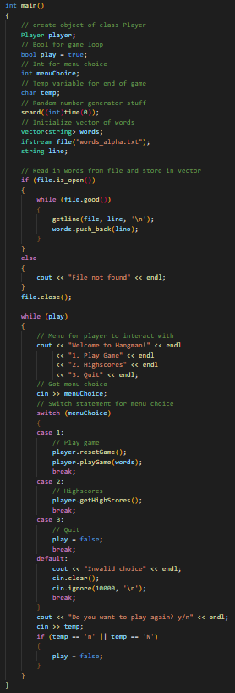

Time complexity: O(n4)

* A call to Player::playGame() is O(n3) and is in a loop, so main is O(n4).

Hangman Function:

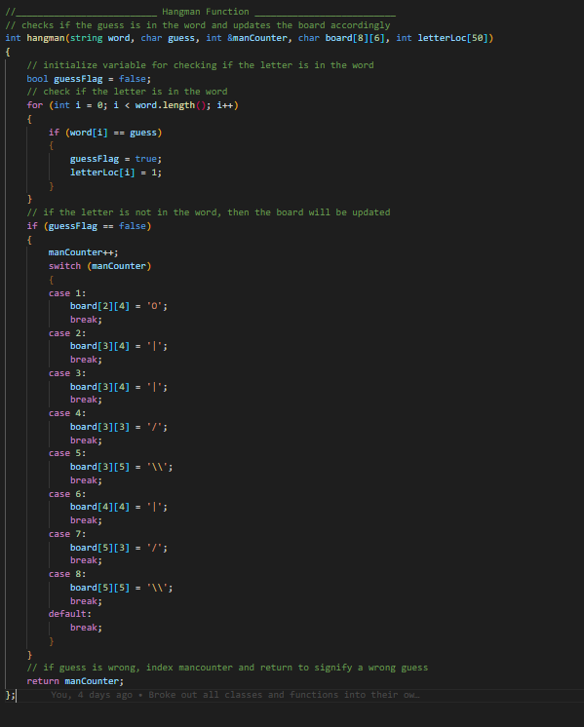

Time Complexity: O(n)

* The time complexity is O(n) because it has one for loop that depends on the input size.

playGame Function:

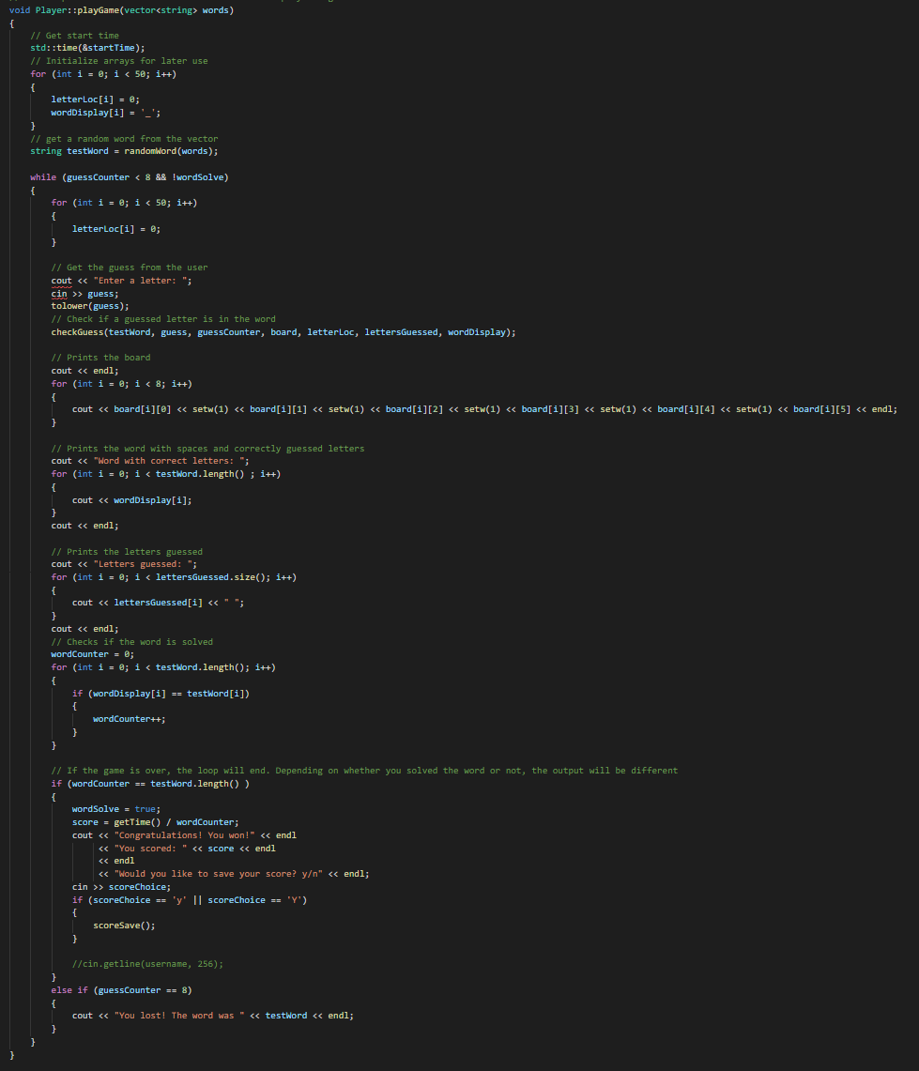

Time Complexity: O(n3)

* The time complexity is O(n3) because a call to saveScore(), O(n2), in the loop.

checkGuess Function:

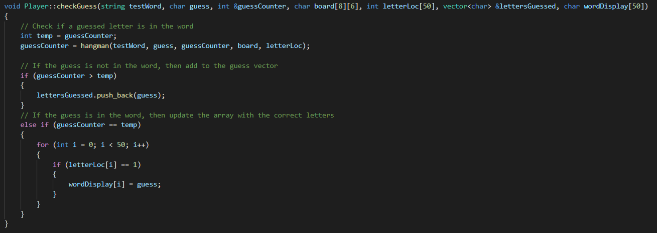

Time Complexity: O(n)

* Though there is a call to hangman() O(n).

randomWord Function:

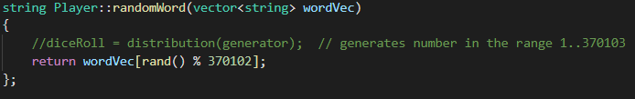

Time Complexity: O(1)

* There is one call, so O(1).

resetGame Function:

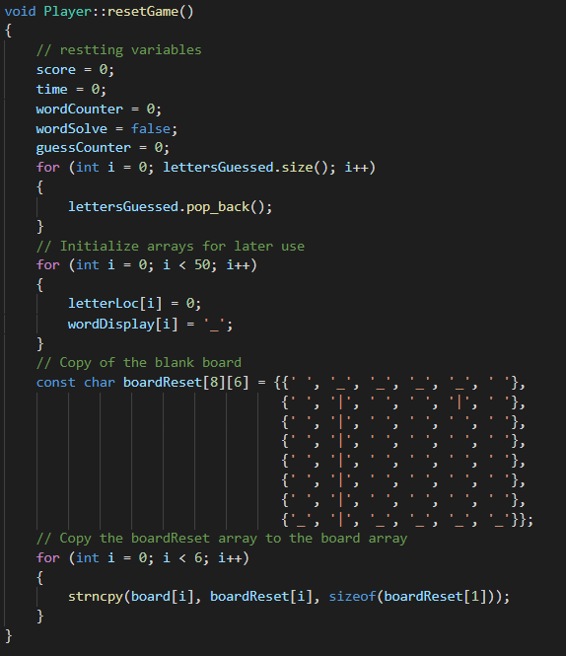

Time Complexity: O(n)

* There is one for loop with variable input size.

getTime

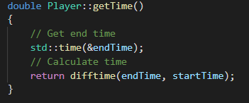

Time Complexity: O(1)

* There are just definitions, so the time complexity is O(1).

scoreSave

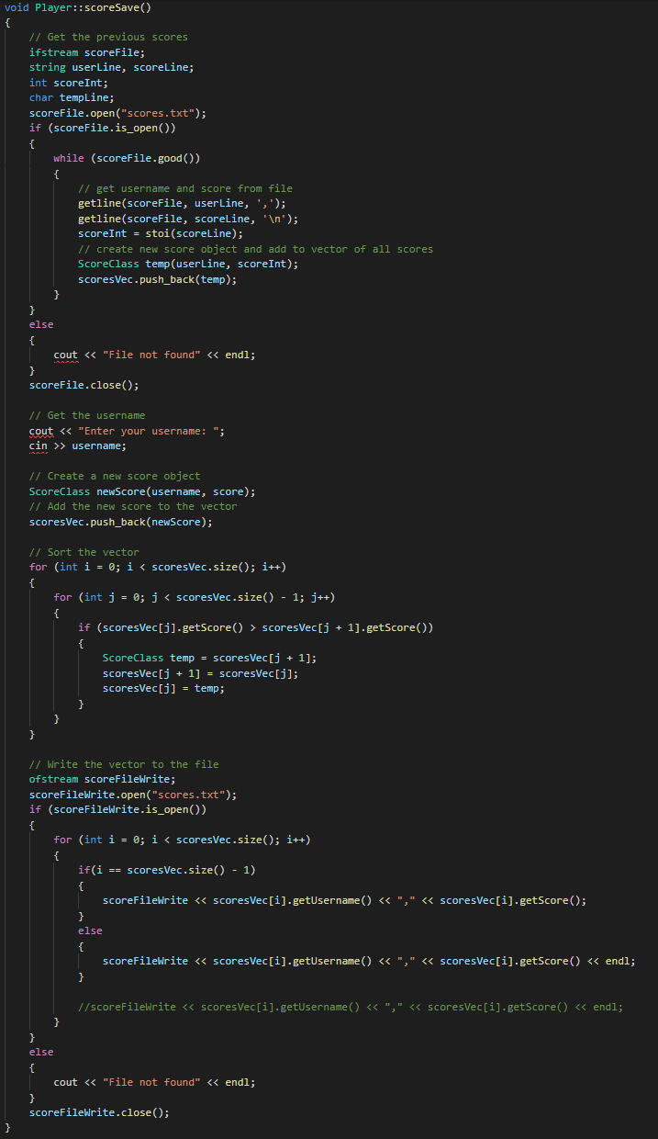

Time Complexity: O(n2)

* There is a for loop in a for loop, so the time complexity is O(n2).

getHighScores

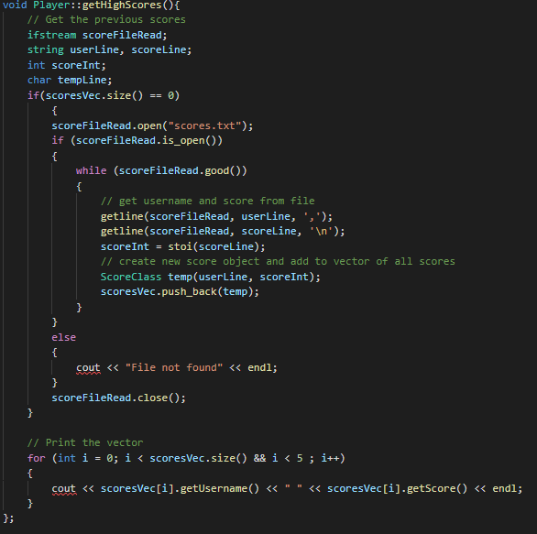

Time Complexity: O(n)

* The time complexity is O(n) since there are two separate loops.

ScoreClass

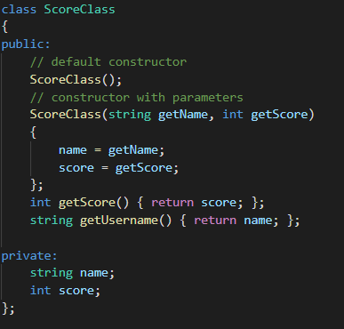

Time Complexity of default constructor: O(1)

* There are just definitions so, O(1).

Time Complexity of constructor with parameters: O(1)

* There are just definitions so, O(1).

Time Complexity of getScore: O(1)

* There are just definitions so, O(1).

Time Complexity of getUsername: O(1)

* There are just definitions so, O(1).